**Genetic Algorithm Program Manual**

**Steps:**

**1.** Determine the Target Genes (e.g. Hello World).

**2.** Define the Population Size (e.g. 400).

**3.** Define the Mutation Probability (e.g. 20%)

**4.** Select a Selection Type function (e.g. Tournament).

a. If Tournament Selection is selected define the tournament size (e.g. 2).

**5.** Define the Crossover Probability (e.g. 95%).

**6.** Select a Crossover Type function (e.g. One Point).

**7.** Determine if Elitism is necessary.

**8 (Optional).** If Elitism is enabled define the Elitism percentage (e.g. 25%).

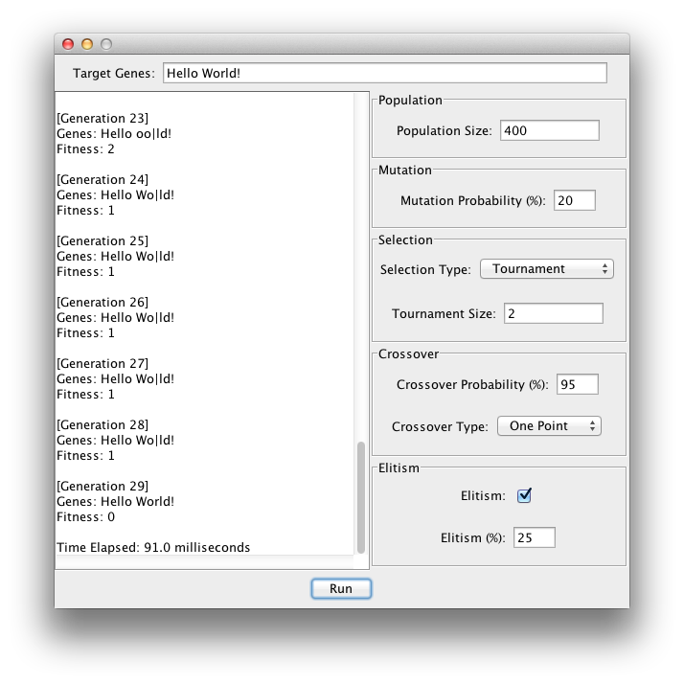**9.** Press the Run button.